**Implementation**

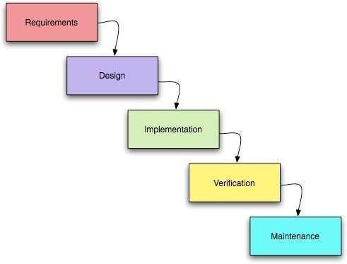

This project is based on the database, web based techniques. To keep the records in the database it uses MySQL software which is one of the best and the easiest databases to keep information. This project uses Bootstrap ,html,css as the front-end web based application which is a php based Programming and has connectivity with MySQL. This system is developed using PHP and MYSQL.This is the web application .In this system Admin gets logged in by valid username and password. Admin can add new Employees, add new Department, add new Pay Grade for the employees,also add stock of the company Admin can set the ‘from’ and ‘to’ date worked by an employee in a department with specific pay grade. The Admin can generate an automated monthly salary of an employee. The admin can view all the past records of any recorded employee.

* **Area of implementation:**

In this project, we used data Mining as an area of implementation for company erp management system

**Algorithm**

**Agile Algorithm**

Itis one of the simplest and effective processes to turn a vision for a business need into software solutions. Agile is a term used to describe software development approaches that employ continual planning, learning, improvement, team collaboration, evolutionary development, and early delivery. It encourages flexible responses to change.

**The agile algorithm emphasizes four core values.**

1. Individual and team interactions over processes and tools
2. Working software over comprehensive documentation
3. Customer collaboration over contract negotiation
4. Responding to change over following a plan

**Mathematical model**

The manufacturing process is made up of a sequence of production activities in the production network following a pre-defined technological sequence. On their route through the production system, the items, raw material, semi-manufactured products and finished products wait in queues for release conditions and are subjected to fabrication or assembly operations until they reach the last production stage. represents the sequence of production activities for one product in three periods of time. Decisions to be taken, before each production resource, are quantity of raw material, demand to be supplied and production level for each group of machinery in each period of time. Cost and capacity are associated with each production stage (processing, transportation, assembling and storage activities). Costs and capacities can be different for each time period .

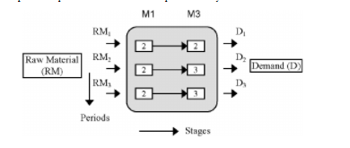

**System Diagram**

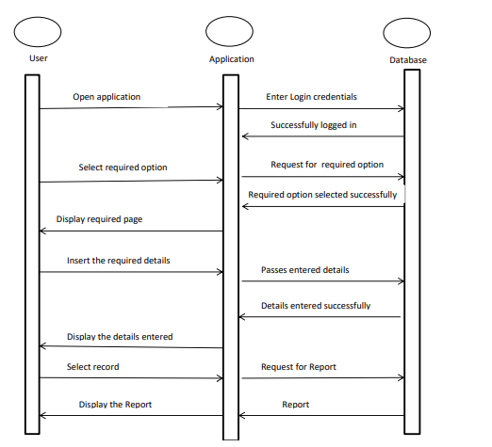

**Dfd Diagrams**

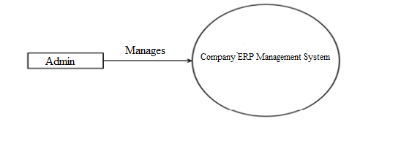

**DFD level 0**

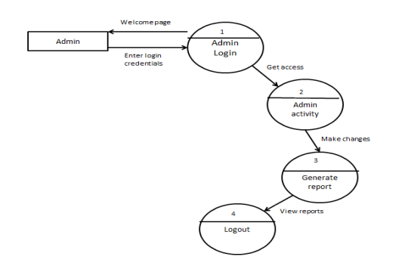

**DFD level 1**

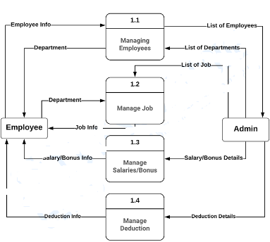

**DFD level 2**